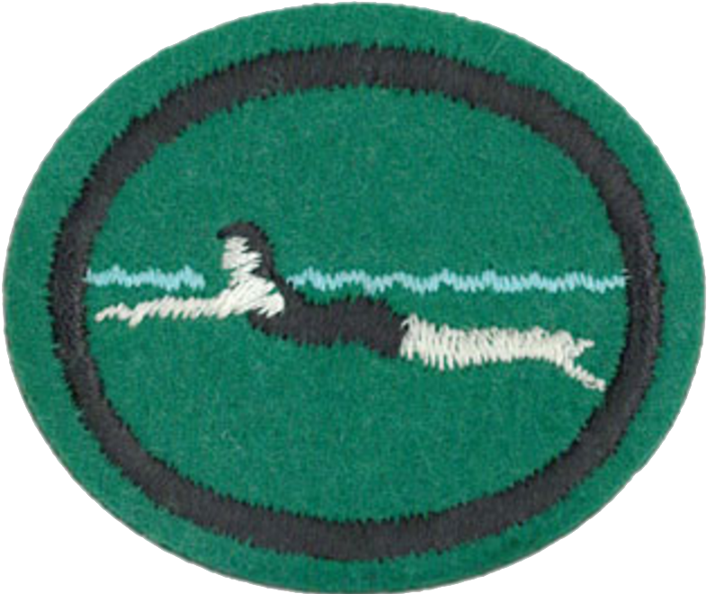
Beginner Swimmer

Receive the American Red Cross Level 3 Stroke Development or YMCA equivalent in Swimming–Beginner's OR pass the following requirements:

- Have completed the Water Safety Honor Requirements

- Water Entry Skills:

a. Enter water by jumping from the side of the pool, or from into the water from a dock into a safe area for jumping.
b. Headfirst entry from the side in a sitting position.
c. Headfirst entry from the side in a kneeling position.

- Breath Control and Submerging:

a. Bobbing while moving toward safety – demonstrate in chest-deep water at least 5 times.
b. Demonstrate rotary breathing, at least 10 times.

- Buoyancy:

a. On front, demonstrate the survival float, at least 30 seconds in deep water.
b. On back, demonstrate moving into a back float in deep water, and hold the float at least 30 seconds.

- Changing Positions:

a. Change from a vertical to horizontal position on the front, in deep water.
b. Change from a vertical to horizontal position on the back, in deep water.

- Treading Water:

a. Demonstrate treading water for at least 30 seconds in deep water.

- Front Swim:

a. Push off in a streamline position, then begin the flutter kick. Kick in streamline position 3-5 body lengths.
b. Push off in a streamline position, then begin the dolphin kick. Demonstrate 3-5 body lengths.
c. Front crawl, at least 15 yards, with good rotary breathing.

8. Back Swim:
- Elementary backstroke, demonstrate smooth finning and whip kick for at least 15 yards.

9. Side Swim:
- Demonstrate, at least 10 yards, the side scissors kick.

10. Water Safety:

a. Reach or Throw, Don’t Go—reaching assists, demonstrate.
b. Think Twice Before Going Near Cold Water or Ice—discuss/demonstrate.
c. Look Before You Leap—understand and demonstrate.
11. Passing Skills:
a. Jump into chest-deep water from the side, swim front crawl for 15 yards, maintain positions by treading water or floating for 30 seconds, and swim elementary backstroke for 15 yards.

