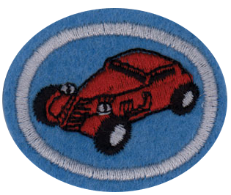
Pinewood Debry Honor

1. Name the four basic components of a Pinewood Derby car.
Body, Wheels, Axle, & Weights

2. Cars must meet the basic following requirements:
- Must be made during the current calendar year or Pathfinder club year
- Width of car shall not exceed 2 3/4” (70 mm)
- Length of car shall not exceed 7”. (178 mm)
- Weight of car shall not exceed 5 oz. (142 grams)
- Width between wheels shall be 1-3/4” (44 mm)
- Height from bottom of car to bottom of tires shall be 3/8” (10 mm)
- Use only axles, wheels, and wood provided in the kit you purchase
- Wheel bearings, washers, and bushings are prohibited

3. Know how to use safely the following while building your project:
- Saw Wood rasp Course sandpaper Fine sandpaper
- Wood plane Hammer Shaping stick Principles of safety
- Wear protective goggles, gloves, and a dust mask to protect your eyes, hands, and lungs.
- Don’t melt lead to add for weight. It is not only a very dangerous operation, but also toxic.
- Children should not use power tools without adult supervision.
- If power tools are used, ensure that all safety devices associated with the tools are used. Use this opportunity to instruct the Pathfinder on the safe operation of power tools.

4. Know the basic steps in designing a car:

a. Design
Draw a design on paper then cut it out and use it as a template. Use graph paper. Draw a side and top view on the paper by tracing around the block of wood.

